PHYTOCHEMICAL ANALYSIS AND ANTIMICROBIAL ACTIVITY OF CATHARANTHUS ROSEUS L.(G.) DON
K. Rekha¹, Prof. M. Mamatha²
1. Department of Botany, Telangana University, Dichpally, Nizamabad, Telangana, India.
2. Department of Basics and Social Sciences, FCRI, Mulugu, Hyderabad, Telangana, India.
Abstract:
Plants serve as crucial reservoirs of pharmaceutical drugs, as well as being utilized in traditional medicine for therapeutic intentions. While it is possible to create these substances in a laboratory setting, the process of synthesizing them is challenging, leading to limited production and impractical economic feasibility. Catharanthus roseus L.(G.) Don. is a deciduous perennial plant with dark green and lustrous foliage that belongs to the Apocyanaceae family which is rich in alkaloids and medicinal properties. The phytochemical screening of Catharanthus roseus leaves showed that the presence of Saponins, Tannins, Triterpenes, Alkaloids, Flavonoids and starch. In antibacterial activity, leaf extract showed high activity against Bacillus subtilis and Streptococcus pneumoniae at low concentration (25%) compared with Pseudomonas aeruginosa and Proteus vulgaris. In antifungal activity, leaf extract showed high activity against Aspergillus flavus at low concentration (25%) compared with Aspergillus niger, Rhizoctonia solani, Fusarium oxysporum. The current study generally found that Catharanthus roseus has the potential to be used for extracting plant compounds. These compounds could be used to develop scientific evidence-based antibacterial and antifungal products for treating bacterial and fungal infections in the future.
Keywords: Catharanthus roseus, Phyto-chemical analysis, Antibacterial activity, Antifungal activity
Introduction:
Medicinal plant products possess the capacity to mitigate the adverse effects of specific chemotherapeutic medications and enhance longevity and general state of health. Hence, it is evident that there has been a surge in worldwide fascination with the medicinal capabilities of plants in the past few decades (Kaushik et al., 2002). Catharanthus roseus L.(G.) Don. is a perennial plant that sheds its leaves and belongs to the Apocyanaceae family. It has dark green and shiny foliage. C. roseus has been found to contain approximately 70 different types of alkaloids, specifically indole alkaloids, and chemotherapeutic compounds. These substances have been proven to be effective in treating various types of cancer, such as breast cancer, lung cancer, uterine cancer, melanomas, Hodgkin's lymphoma, and non-Hodgkin's lymphoma. Catharanthus roseus L. (G.) Don. has traditionally been used in folk medicine to treat diabetes and hypertension. It was believed to augment the production of insulin as a therapeutic approach for diabetes. However, modern science acknowledges the anticancer and pain-relieving properties of alkaloids and chemotherapeutic medicines that are produced from C. roseus (Verpoorte 1998). The primary purpose of cultivating the plant is to harness its alkaloids, which exhibit anticancer effects (Jaleel et al., 2009). Recent study has discovered supplementary chemical components in this plant that demonstrate strong antiradical activity. The newly identified phenolic compounds have been detected in several parts of the plant, such as the seed, stem, leaf, and petal. Additionally, the root contains organic acids (Pereira et al., 2010). The different components of this plant also exhibit antibacterial characteristics (Patil and Ghosh 2010).
The antimicrobial efficacy of methanolic extracts from different parts of C. roseus has been evaluated. The leaf extracts demonstrated a significantly higher level of activity, suggesting that the bioactive compounds present in C. roseus can be employed as an antibacterial agent (Nayak and Pereira 2006). Various investigations have demonstrated the antiviral and antibacterial characteristics of the alkaloids derived from C. roseus as a result of their notable secondary metabolites (Koul et al., 2013). Zoonotic bacteria encompass pathogenic gram-negative bacteria, such as E. coli, as well as gram-positive bacteria, such S. aureus. The worldwide escalation of antimicrobial-resistant bacteria presents a substantial apprehension for the well-being of both humans and animals. The escalating antibiotic resistance of S. aureus is a major concern, exhibiting diverse rates in different geographical areas (Mekonnen et al., 2018). As to Atef et al., (2019), S. aureus is the primary factor responsible for hospital-acquired wound infections. Aspergillus flavus is a common cause of otomycosis, a disorder characterized by fungal infections in the ear. This infection can cause discomfort, temporary hearing loss, and, in severe cases, damage to the ear canal and tympanic membrane. Individuals with a normal immune system can develop long-lasting respiratory infections or allergy disorders as a result of Aspergillus niger (Chaman et al., 2013).
Materials and Methods
Plant material and extract preparation
The leaves of C. roseus was gathered from the nearby area and dried in a shaded environment. Subsequently, it was pulverized into a fine powder using an electric blender. A 50 g quantity of the fine powder was mixed with 100 ml of ethanol and left to dissolve for 20 hours at room temperature. The combination underwent filtration using a fine muslin cloth, followed by filter paper (Whatman No: 1). The filtrate was subjected to evaporation in a water bath at a temperature of 40°C until it was completely dried. The resulting residue, which was transparent, was utilized for the investigation. The extract underwent preliminary phytochemical analysis, including testing for saponins, tannins, triterpenes, alkaloids, and flavonoids.
Antibacterial activity screening of the methanolic crude extracts
The methanolic crude extracts (25%, 50% and 75%) were assessed using the disc diffusion method using ATCC (American Type Culture Collection) and NCTC (National Collection of Type Cultures) strains. The bacterial strains consisted of four types: two Gram-positive strains, namely Bacillus subtilis (NCTC 8236) and Streptococcus pneumonia (ATCC 49619), and two Gram-negative strains, namely Proteus vulgaris (ATCC 6380) and Pseudomonas aeruginosa (ATCC 27853).
Isolation and Identification of fungal pathogens
Aspergillus niger- Allium cepa (Onion-Black Mold)
Aspergillus flavus- Arachis hypogaea (Pea nut seeds)
Fusarium oxysporum- Solanum lycopersicum (Tomato fruit)
Rhizoctonia solani – Zea mays (Infected corn)
The infected parts of the plants were treated with 70% ethanol to remove any surface contaminants. They were then soaked in a solution of 0.3% sodium hypochlorite for 10 minutes. After that, they were rinsed with sterile distilled water. The parts were then placed on potato dextrose agar (PDA) medium in petri dishes and kept in a dark environment at a temperature of 28 °C for a period of 7 days. After 7 days of development in PDA media, spores were gathered in sterile distilled water. Pure cultures were preserved on PDA slants and Petriplates at a temperature of 4 °C.
Well diffusion method:
The well diffusion method was employed to assess the antifungal activity. A 6 mm diameter well was made by using a cork borer with a constant diameter. The wells impregnated with extract of varied concentrations that had been inoculated with the test organism. The plates were placed in an incubator at an appropriate temperature and examined for the presence of a zone of inhibition after a period of 24-72 hours.
Results and Discussion
Table 1: Phytochemical Evaluation of Catharanthus roseus shoots
S.No | Phytochemical | Result
1 | Saponins | +
2 | Tannins | +
3 | Triterpenes | -
4 | Alkaloids | +
5 | Flavonoids | +
6 | starch | -

The phytochemical screening of Catharanthus roseus shoot showed that the presence of Saponins, Tannins, Alkaloids, and Flavonoids.
Table 2: Phytochemical Evaluation of Catharanthus roseus roots
S.No | Phytochemical | Result
1 | Saponins | +
2 | Tannins | +
3 | Triterpenes | -
4 | Alkaloids | +
5 | Flavonoids | +
6 | Starch | -
The phytochemical screening of Catharanthus roseus roots showed that the presence of Saponins, Tannins, Alkaloids, and Flavonoids.
Table 3: Phytochemical Evaluation of Catharanthus roseus leaves
S.No | Phytochemical | Result
1 | Saponins | +
2 | Tannins | +
3 | Triterpenes | +
4 | Alkaloids | +
5 | Flavonoids | +
6 | Starch | +
The phytochemical screening of Catharanthus roseus leaves showed that the presence of Saponins, Tannins, Triterpenes, Alkaloids, Flavonoids and starch.
Table 4: Anti-Bacterial Activity of Catharanthus roseus
Conc | Bacillus subtilis (mm) | Proteus vulgaris (mm) | Pseudomonas aeruginosa (mm) | Streptococcus pneumoniae (mm)
25% | 15 | 12 | 13 | 14
50% | 16 | 14 | 15 | 15
75% | 18 | 17 | 16 | 17

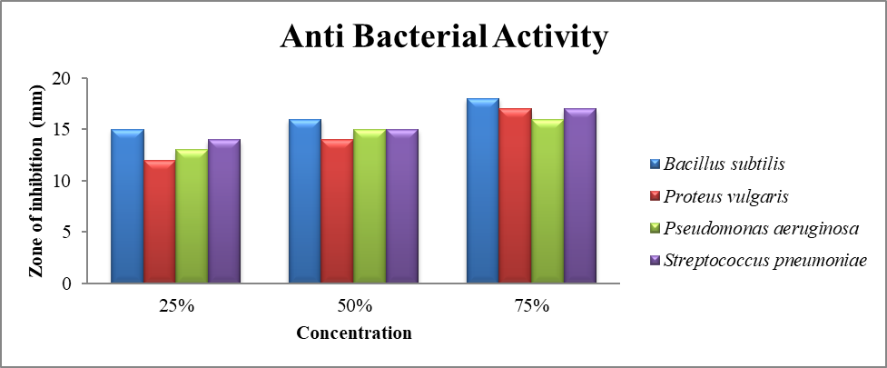
Bacillus subtilis
Proteus vulgaris
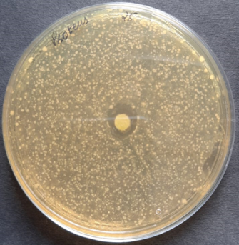
Pseudomonas aeruginosa
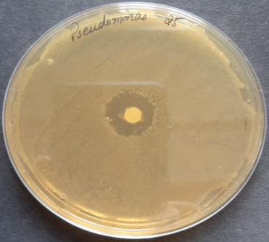
Streptococcus pneumoniae
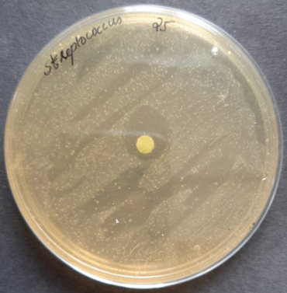
In antibacterial activity, leaf extract showed high activity against Bacillus subtilis and Streptococcus pneumoniae at low concentration (25%) compared with Pseudomonas aeruginosa and Proteus vulgaris.
Table 5: Antifungal activity
Conc. | Aspergillus flavus | Aspergillus niger | Rhizoctonia solani | Fusarium oxysporum
Control | 0 | 0 | 0 | 0
25% | 15 | 11 | 14 | 13
50% | 16 | 13 | 16 | 14
75% | 17 | 15 | 16 | 15

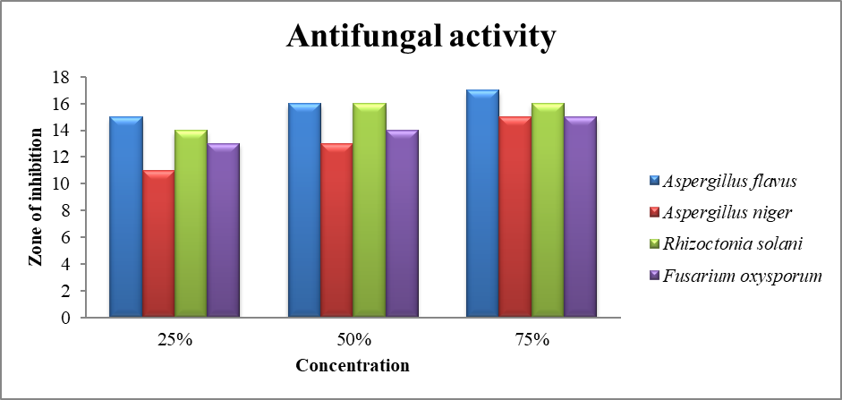
Aspergillus flavus
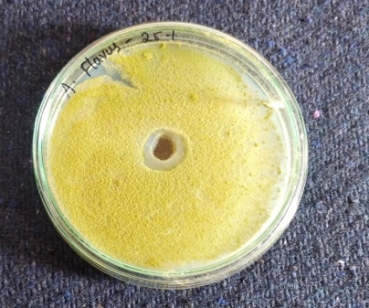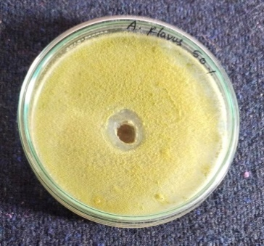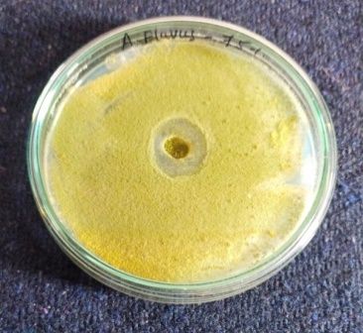
Aspergillus niger
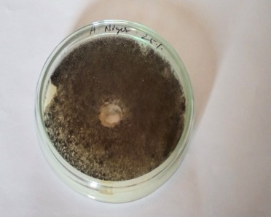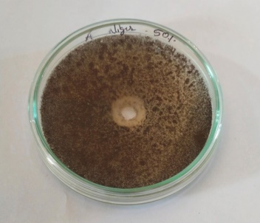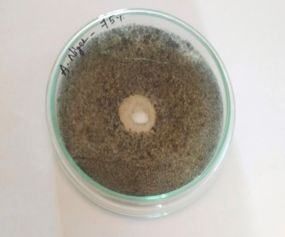
Fusarium oxysporum
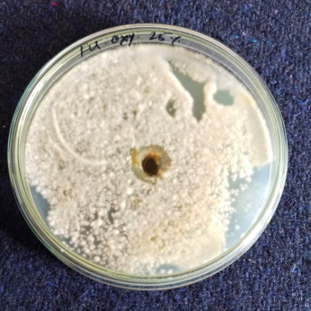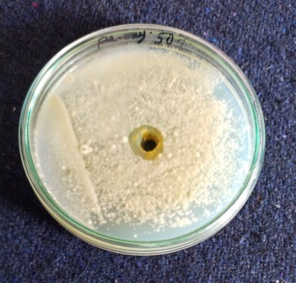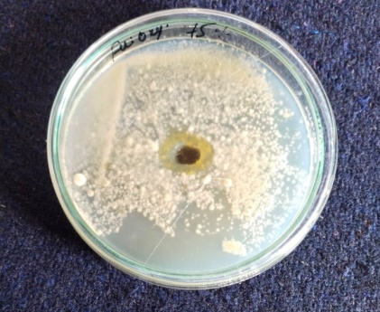
Rhizoctonia solani
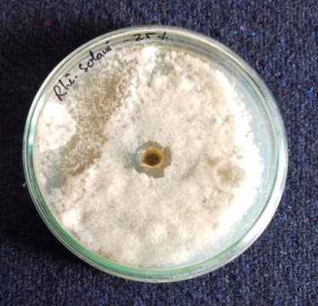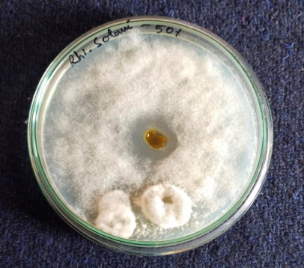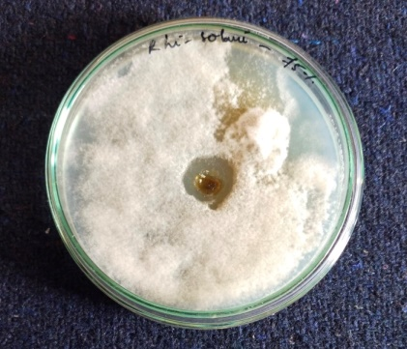
In antifungal activity, leaf extract showed high activity against Aspergillus flavus at low concentration (25%) compared with Aspergillus niger, Rhizoctonia solani, Fusarium oxysporum.
Discussion
The literature survey reveals that this plant has mostly been investigated for its anti-cancer and anti-diabetic qualities. To date, there have been limited investigations conducted on the antimicrobial effects of plant extracts. Thus, this work specifically examines the antimicrobial characteristics of the leaf extracts. While these extracts may not have direct therapeutic applications, they can certainly be utilized as a preventive agent in locations where certain diseases may arise endemically or even on a pandemic scale. Removing the stress on specific vaccine development will greatly help protect the population, particularly in developing nations, from the infection. This disease alters its invasive methods by changing its antigenic character.
The foregoing results indicate that the leaf extract included several indole alkaloids and a few phenolic substances. Phenolic chemicals has antibacterial effects. The importance of these chemicals lies in their ability to replace prolonged antibiotic treatment, particularly in cases of chronic kidney infection, bacterial endocarditis, and carrier states of typhoid when the bacteria remain in the gall bladder. These molecules, which have little adverse effects, can be readily substituted for antibiotics.
Indole alkaloids do not directly exhibit antimicrobial effects. Instead, they enhance the immune system, which is responsible for combating microorganisms. Likewise, a robust immune system will also handle numerous initial stages in specific cancer development. However, if the immune system is insufficiently strong or the organism is highly potent, additional medication must be administered alongside these chemicals to demonstrate notable antimicrobial efficacy.
Conclusion
The phytochemical screening of Catharanthus roseus leaves showed that the presence of Saponins, Tannins, Triterpenes, Alkaloids, Flavonoids and starch. Based on high Phytochemicals we selected Catharanthus roseus leaves for antimicrobial activity. In antibacterial activity, leaf extract showed high activity against Bacillus subtilis and Streptococcus pneumoniae at low concentration (25%) compared with Pseudomonas aeruginosa and Proteus vulgaris. In antifungal activity, leaf extract showed high activity against Aspergillus flavus at low concentration (25%) compared with Aspergillus niger, Rhizoctonia solani, Fusarium oxysporum.
The current study generally found that Catharanthus roseus has the potential to be used for extracting plant compounds. These compounds could be used to develop scientific evidence-based antibacterial and antifungal products for treating bacterial and fungal infections in the future.
References
- Atef NM, Shanab SM, Negm SI, Abbas YA. 2019. Evaluation of antimicrobial activity of some plant extracts against antibiotic susceptible and resistant bacterial strains causing wound infection. Bull Nat Res Cen 43 (1): 144-149.
- Chaman S, Garima S, Shalini, Anil KR. 2013. Study of Antimicrobial properties of Catharanthus roseus by agar well diffusion method, Intl Res J Pharm Appl Sci 3 (5):65-68.
- Jaleel, C.A., R. Gopi and R. Paneerselvam, 2009. Alterations in non-enzymatic antioxidant components of Catharanthus roseus exposed to paclobutrazol, gibberellic acid and Pseudomonas fluorescens, Plant Omics J., 2: 30-40.
- Kaushik, P. and A.K. Dhiman, 2002. Medicinal Plants and Raw Drugs of India, P. XII+623. Retrieved from: http://www.vedicbooks.net/medicinal-plants-andraw- drugs-of-india-p-13886.html.
- Koul M, Lakra NS, Chandra R, Chandra S. 2013. Catharanthus roseus and prospects of its endophytes: a new avenue for production of bioactive metabolites, Intl J Pharmaceut Sci Res 4 (7): 2705-2716.
- Mekonnen SA, Lam TJGM, Hoekstra J, Rutten VP, Tessema TS, Broens EM. 2018. Characterization of Staphylococcus aureus isolated from milk samples ofdairy cows in small holder farms of North-Western Ethiopia. BMC Vet Res 14: 246-250.
- Nayak BS, Pereira LMP. 2006. Catharanthus roseus flower extract has wound-healing activity in Sprague Dawley rats, BMC Compl Altern Med 6 (1): 41. DOI: 10.1186/1472-6882-6-41.
- Patil PJ, Ghosh JS. 2010. Antimicrobial activity of Catharanthus roseus-a detailed study, British J Pharmacol Toxicol 1 (1): 40-44.
- Pereira DM, Faria J, Gaspar L, Ferreres F, Valentao P, Sottomayor M, Andrade PB. 2010, Exploiting Catharanthus roseus roots: Source of antioxidants. Food Chem 121: 56-61.
- Verpoorte R. Exploration of Nature’s chemo diversity: the role of secondary metabolic as lead for drug development, Drug Dev. Today 1998; 3:232-238.

