SCAVENGING ACTIVITIES OF RHINACANTHUS NASUTUS (L.) KURZ. LEAVES IN CHLOROFORM EXTRACT

Catherine Sheeja V², Anami Augustus Arul A¹, Blessy R², Ani Besant S², Hanna Jeeja Alexander²
¹Assistant Professor, Department of Botany, Holy Cross College (Autonomous), Nagercoil.
²Research Scholar, PG and Research Department of Botany, Holy Cross College (Autonomous), Nagercoil.
Affiliated to Manonmaniam Sundaranar University, Abhisekapatti, Tirunelveli, Tamil Nadu, India
Corresponding author: catherinesheeja80@gmail.com
ABSTRACT
Rhinacanthus nasutus (l.) Kurz was evaluated for its antioxidant activity in this study. Rhinacanthus nasutus is a member of the Acanthaceae family. Folk medicine uses it as a remedy for liver disorders, skin disorders, and other pharmacological effects. It was sought to determine the antioxidant activity of Rhinacanthus nasutus (L.) Kurz. leaf extract using DPPH assay, H2O2, NO and SOD scavenging activity methods. As compared to DPPH, Hydrogen peroxide, Nitric oxide and Sodium oxide, Rhinacanthus nasutus leaf extract exhibited better antioxidant activity against Nitric oxide.
INTRODUCTION
As the "Emporium of medicinal plants", India is well known for its medicinal plants. With approximately 12600 species, it is one of the 12 mega biodiversity centers with two hot spots of biodiversity in the Western Ghats and the northeastern region [1]. Traditional medicine provides primary health care to about 80% of the population in developing countries [2]. Many bioactive compounds can be produced by plants. The traditional healthcare systems of traditional societies rely heavily on medicinal plants [3]
This species of Rhinacanthus nasutus (L.) Kurz. belongs to the Acanthaceae family. There are several common names for this plant, such as Snake Jasmine, Nagamalli, and Puzhukkolli [4]. An antioxidant is a physiologic substance that acts against excessive oxidative stress and can be found in both endogenous and exogenous sources [5]. Food additives, preservatives, and supplements often contain antioxidants such as BHT, BHA, and plant extracts [6]. It has shown potential effects in treating diseases such as cancer, liver disorders, skin diseases, peptic ulcers, helminthiasis, scurvy, inflammation and obesity in some studies [7].

The aim of this study is to investigate the antioxidant properties of Rhinacanthus nasutus. In traditional medicine, different parts of R. nasutus have been used to treat conditions such as eczema, pulmonary tuberculosis, herpes, hepatitis, diabetes and hypertension [8]. Antioxidant properties have been reported for R.nasutus extracts in foods, cosmetics, and pharmaceuticals. According to [9] extracts of R. nasutus in cosmetics may slow aging and hair loss.
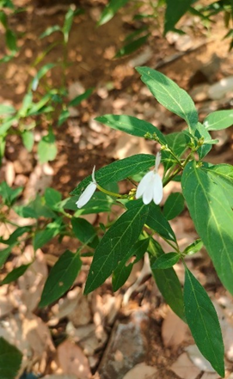
MATERIALS AND METHODS
Collection of plant sample
Fresh Rhinacanthus nasutus (L.) Kurz leaves were collected from Arumanai region in Vilavankode taluk of Kanyakumari district, Tamilnadu. Plant specimens were deposited in the herbarium of Holy Cross College (Autonomous), Nagercoil after identification.
Preparation of plant extract
Fresh leaves were washed with water and dried in the shade. In the Soxhlet apparatus, 100 grams of powdered leaves were extracted with chloroform. The extract was cooled to room temperature and evaporated under reduced pressure in a rotatory evaporator. After six hours of extraction, the final sample was analysed for GC-MS analysis.

ANTIOXIDANT ANALYSIS OF RHINACANTHUS NASUTUS
Phytochemicals present in plants have a complex structure that makes it possible to evaluate antioxidants in different ways [10]. In addition to DPPH [11], hydrogen peroxide [12], superoxide [13], and nitric oxide [14], various free radical scavengers were evaluated. Rutin is a natural antioxidant called rutoside. Vegetables, fruits, and medicinal herbs are the main sources of this compound. According to [15], rutin has various pharmacological properties including antibacterial, antitumor, anti-inflammatory, antiallergic, antiviral, antiplatelet, and antihypertensive properties.

RESULTS
According to [16] found that free radicals play a role in a wide range of diseases such as neurodegenerative diseases, cancer and HIV/AIDS. Plant extract antioxidant activity can be quantified in different ways; in fact, at least two methods should be used [17]. DPPH provides a quick and easy way to evaluate antioxidants. In DPPH analysis, plants belonging to the Acanthaceae, Leguminosae (subfamilies Papilionoideae and Caesalpinioideae) and Moraceae showed lower activity levels [18].

Rhinacanthus nasutus leaves extracts were highly antioxidant-active against all free radicals. DPPH scavenging activity of Rhinacanthus nasutus extract at 100g/mL concentration was the highest of all concentrations. One of the most commonly used methods for evaluating plant extract antioxidant activity is DPPH radical scavenging activity. The standard used was Rutin. In Table 1, different concentrations of plant extract (20-100g/ml), as well as standard Rutin, were tested for their ability to scavenge DPPH. DPPH scavenging activity ranges from low to high. Increasing concentrations of leaf extract showed an increase in scavenging activity. Similar findings have been reported [19,20]

The rutin scavenges more free radicals than the sample extract. As a result, natural antioxidants from plants have been shown to have greater effectiveness in quenching reactive species levels than synthetic individual dietary antioxidants. Food plants are able to produce food due to the synergistic actions of so many biomolecules. These compounds have antioxidant properties due to their ability to form stable and harmless metabolites from reactive species or to scavenge reactive oxygen and nitrogen species via redox mechanisms [21].

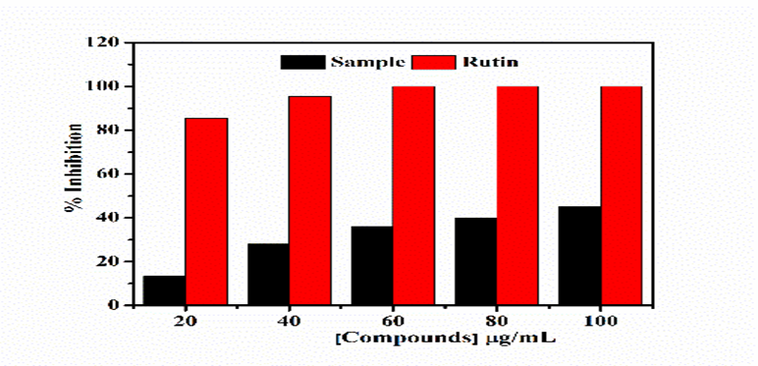
Figure 1. DPPH Free radical scavenging activity of Rhinacanthus nasutus(L.)Kurz leaf extract

There was a noticeable difference in scavenging activity between concentrations of 100 g/mL and lower concentrations. There is also evidence that Mukia maderaspatana can scavenge H2O2 in a dose-dependent manner, and the capacity of scavenging H2O2 has been demonstrated [22]. Results showed that plant extracts have minimal H2O2 scavenging activities compared to standard Rutin
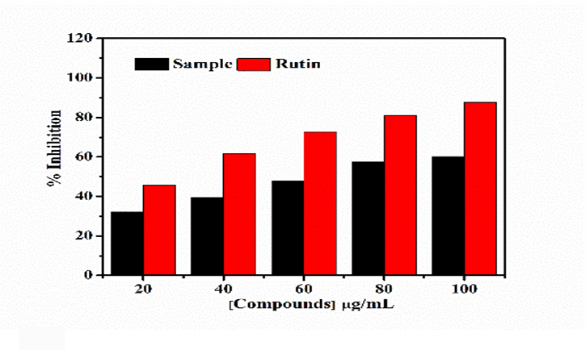
Figure 2. H₂O₂ scavenging activity of Rhinacanthus nasutus (L.) Kurz leaf extract NO Scavenging Activity
Inhibition percentages of 68% were found at 100 g/mL concentrations for Rhinacanthus nasutus extract. The minimum percentage of inhibition produced was 35.6% at a concentration of 20g/mL. NO plays a number of biological functions, including antimicrobial, antitumor, smooth muscle relaxation, neuronal messenger, inhibition of platelet aggregation, and regulating cell-mediated toxicity [23].
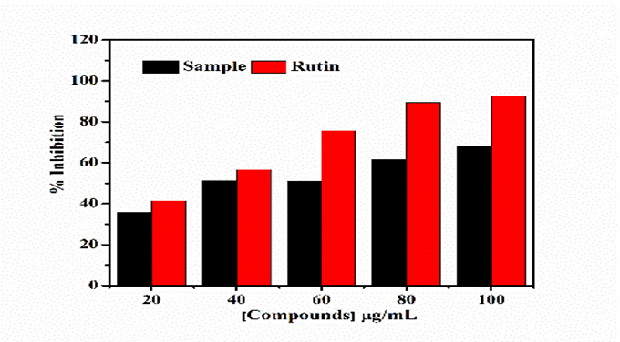
Figure 3. NO scavenging activity of Rhinacanthus nasutus (L.) Kurz leaf extract

Scavenging of Superoxide radical
At concentrations of 20 - 100 g/mL, chloroform leaves extract ranges from 19.3% to 48.1%. According to the results, 19.3% of the scavenging activity was observed at 20g/mL while 100g/mL produced the highest scavenging activity. The activity of methanolic extracts of the leaves of Ocimum sanctum L. against superoxide radicals is similar to our results [24]. Based on the earlier findings of [25], there are several diseases associated with the scavenging of superoxide radicals, which are reactive oxygen species that damage cells and DNA. A study conducted by [26] demonstrated that flavonoids are effective antioxidants primarily because they scavenge superoxide anions. As shown in figure 3, superoxide radical scavenging activities of the plant extract and reference compound are significantly enhanced by increasing concentrations. In our study Rutin was used as standard. Similarly [27] has used rutin as standard.
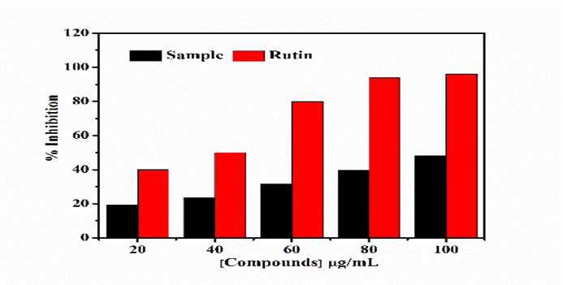
Figure 4.SOD scavenging activity of Rhinacanthus nasutus (L.) Kurz leaf extract
Antioxidants are molecules that protect your body from free radical damage. In excess, free radicals can damage the body. In addition to diabetes, heart disease and cancer, they are linked to several illnesses. As a result of free radicals such as superoxide radicals (O2), antioxidants significantly slow or prevent the oxidative or oxygen-based damage. Hydroxyl radical (OH) and non-free radical species such as H2O2 and singlet oxygen (1O2) are associated with cellular and metabolic injury, accelerated aging, cancer, cardiovascular disease, neurodegenerative diseases, and inflammation [28-30].
A perfect example of oxygen free radicals is reactive oxygen species. It is not only free radical molecules found in reactive oxygen species that can affect lipid oxidation, but also non-free radical molecules as well. Reactive oxygen species that are not free radicals include hydrogen peroxide (H2O2), hydrochloric acid (HCl), ozone (O3), and molecular oxygen (O2) [31]. Research has demonstrated that phytochemicals in common fruits and vegetables can have complementary and overlaid mechanisms of action, including the scavenging of oxidative agents, the stimulation of the immune system, hormone metabolism, and antibacterial and antiviral properties [32]. Due to the toxicity and mutagenic effects of synthetic antioxidants, natural antioxidants have been explored as an alternative [33].

CONCLUSION
Biologically synthesized antioxidants are crucial in preventing and treating chronic diseases by reducing oxidative damage to cellular components caused by free radicals. In vitro antioxidant activity was found to be significantly increased in Rhinacanthus nasutus extract in all the investigated types. Hence the present study proves that Rhinacanthus nasutus can be further considered in wide manner for its antioxidant property
REFERENCES
1. Amuthavalluvan V. Ethno medicinal practices and traditional healing system of Kattunayakan in Tamilnadu: An anthropological study. International Multidisciplinary Research Journal. 2011 Oct 4;1(7).
2. Nirmaladevi R, Padma PR, Kavitha D. Analyses of the methanolic extract of the leaves of Rhinacanthus nasutus. Journal of Medicinal Plants Research. 2010 Aug 4;4(15):1554-60.
3. Rubalakshmi G, Nirubama K, Prabhakaran S. Structural delving and insilico analysis of proteins of Rhinacanthus Nasutus - an indigenous medicinal plant. JOURNAL OF ADVANCED APPLIED SCIENTIFIC RESEARCH. 2016;1(6):1-3.
4. Bukke S, Raghu PS, Sailaja G, Kedam TR. The study on morphological, phytochemical and pharmacological aspects of Rhinacanthus nasutus (L) Kurz (A review). Journal of Applied Pharmaceutical Science. 2011 Oct 30(Issue):26-32.
5. Rai RR, Phadke MS. Plasma oxidant-antioxidant status in different respiratory disorders. Indian Journal of Clinical Biochemistry. 2006 Sep;21(2):161-4.
6. Zulueta A, Esteve MJ, Frasquet I, Frígola A. Vitamin C, vitamin A, phenolic compounds and total antioxidant capacity of new fruit juice and skim milk mixture beverages marketed in Spain. Food Chemistry. 2007 Jan 1;103(4):1365-74.
7. Suja SR, Latha PG, Pushpangadan P, Rajasekharan S. Evaluation of hepatoprotective effects of Rhinacanthus nasutus root extracts. JOURNAL OF TROPICAL MEDICINAL PLANTS. 2003;4(2):151-8.
8. Siripong P, Yahuafai J, Shimizu K, Ichikawa K, Yonezawa S, Asai T, Kanokmedakul K, Ruchirawat S, Oku N. Antitumor Activity of Liposomal Naphthoquinone Esters Isolated from Thai Medicinal Plant: Rhinacanthus nasutus KURZ. Biological and Pharmaceutical Bulletin. 2006;29(11):2279-83.
9. Wiart C, Kumar K, Yusof MY, Hamimah H, Fauzi ZM, Sulaiman M. Antiviral properties of ent labdene diterpenes of Andrographis paniculata Nees, inhibitors of herpes simplex virus type 1. Phytotherapy Research: An International Journal Devoted to Pharmacological and Toxicological Evaluation of Natural Product Derivatives. 2005 Dec;19(12):1069-70.
10. Singleton VL, Rossi JA. Colorimetry of total phenolics with phosphomolybdic- phosphotungstic acid reagents. Am J Enol Vitic. 1965;16:144–158
11. Serpen A, Capuano E, Fogliano V, Gökmen V. A new procedure to measure the antioxidant activity of insoluble food components. Journal of Agricultural and Food Chemistry. 2007 Sep 19;55(19):7676-81.
12. Patel V, Kelleher M, McGurk M. Clinical use of hydrogen peroxide in surgery and dentistry–why is there a safety issue?. British Dental Journal. 2010 Jan;208(2):61-4.
13. Nishikimi M, Rao NA, Yagi K. The occurrence of superoxide anion in the reaction of reduced phenazine methosulfate and molecular oxygen. Biochemical and biophysical research communications. 1972 Jan 31;46(2):849-54.

14. Cos P, Ying L, Calomme M, Hu JP, Cimanga K, Van Poel B, Pieters L, Vlietinck AJ, Berghe DV. Structure− activity relationship and classification of flavonoids as inhibitors of xanthine oxidase and superoxide scavengers. Journal of natural products. 1998 Jan 23;61(1):71- 6.
15. Patel K, Patel DK. The beneficial role of rutin, a naturally occurring flavonoid in health promotion and disease prevention: a systematic review and update. Bioactive food as dietary interventions for arthritis and related inflammatory diseases. 2019 Jan 1:457-79.
16. Veeru P, Kishor MP, Meenakshi M. Screening of medicinal plant extracts for antioxidant activity. Journal of Medicinal Plants Research. 2009 Aug 31;3(8):608-12.
17. Milan, C.; Hana, C.; Petko, D.; Maria, K.; Anton, S.; Antonín, L. Different methods for control and comparison of the antioxidant properties of vegetables. Food Control 2010, 21, 518–523.
18. Mensor LL, Menezes FS, Leitão GG, Reis AS, Santos TC, Coube CS, Leitão SG. Screening of Brazilian plant extracts for antioxidant activity by the use of DPPH free radical method. Phytotherapy research. 2001 Mar;15(2):127- 30.
19. Prabhakar NR, Kumar GK, Nanduri J, Semenza GL. ROS signaling in systemic and cellular responses to chronic intermittent hypoxia. Antioxidants & redox signaling. 2007 Sep 1;9(9):1397-404.
20. Shu S, Yuan LY, Guo SR, Sun J, Yuan YH. Effects of exogenous spermine on chlorophyll fluorescence, antioxidant system and ultrastructure of chloroplasts in Cucumis sativus L. under salt stress. Plant Physiology and Biochemistry. 2013 Feb 1; 63:209-16.
21. Petrus AJ. Mukia maderaspatana (L.) M. Roemer-A Review of Its Global Distribution, Phytochemical Profile and Antioxidant Capacity. Asian Journal of Chemistry. 2012 Jun 1;24(6).
22. Raja B, Pugalendi KV. Evaluation of antioxidant activity of Melothria maderaspatana in vitro. Central European Journal of Biology. 2010 Apr;5(2):224-30.
23. Hagerman AE, Riedl KM, Jones GA, Sovik KN, Ritchard NT, Hartzfeld PW, Riechel TL. High molecular weight plant polyphenolics (tannins) as biological antioxidants. J. Agric. Food Chem. 1998 May 18;46(5):1887-92.
24. Harichandan SP, Sahu AK, Gautam S, Nemani R. Phytochemical screening and antioxidant activity of methanolic extract of Ocimum sanctum Linn. Leaves. GSC Biological and Pharmaceutical Sciences. 2019 Aug 30;8(2):022-33.
25. Korycka-Dahl M, Richardson T. Photogeneration of superoxide anion in serum of bovine milk and in model systems containing riboflavin and amino acids. Journal of Dairy Science. 1978 Apr 1;61(4):400-7.
26. Robak J, Gryglewski RJ. Flavonoids are scavengers of superoxide anions. Biochemical pharmacology. 1988 Mar 1;37(5):837-41.
27. Sudjarwo, SA, Sudjarwo, KE, Sudjarwo, G.W. 2011. Mechanisms of endothelial cell protection by curcumin in hypercholesterolemia. Journal of Applied Pharmaceutical Science, (Issue), pp.32-35.

28. Ames BN. Dietary carcinogens and anticarcinogens: oxygen radicals and degenerative diseases. Science. 1983 Sep 23;221(4617):1256-64.
29. Stadtman ER, Berlett BS. Reactive oxygen-mediated protein oxidation in aging and disease. Drug metabolism reviews. 1998 Jan 1;30(2):225-43.
30. Sun Y. Free radicals, antioxidant enzymes, and carcinogenesis. Free Radical Biology and Medicine. 1990 Jan 1;8(6):583-99.
31. Halliwell B, Murcia MA, Chirico S, Aruoma OI. Free radicals and antioxidants in food and in vivo: what they do and how they work. Critical Reviews in Food Science & Nutrition. 1995 Jan 1;35(1-2):7-20.
32. Waladkhani AR, Clemens MR. Effect of dietary phytochemicals on cancer development. International journal of molecular medicine. 1998 Apr 1;1(4):747-800.
33. Saritha B, Karpagam, Sumathi. Studies on antioxidant activity, phenol and flavonoid content of Pisonia alba Span. Asian J Pharm Clin Res. 2014;7(3):106-9.

